**Program / Project Name MISYS-30,31 and 48: GFP Requirements**

**Program / Project No.:**

**Document Version:**

**Template Version:**

**Prepared by:**

**Group:**

**Function:**

|  |
| --- |
| RBC Investor & Treasury Services™ is a global brand name and is part of Royal Bank of Canada. RBC Investor & Treasury Services is a specialist provider of asset servicing, custody, payments and treasury services for financial and other institutional investors worldwide. RBC Investor Services™ operates through two primary operating companies, RBC Investor Services Trust and RBC Investor Services Bank S.A., and their branches and affiliates.  In the UK, RBC Investor Services Trust operates through a branch authorized by the Prudential Regulation Authority and regulated by the Financial Conduct Authority and the Prudential Regulation Authority. The Dubai Branch of RBC Investor Services Trust is regulated by the Dubai Financial Services Authority.  In Australia, RBC Investor Services Trust is authorized to carry on financial services business by the Australian Securities and Investments Commission under the AFSL (Australian Financial Services Licence) number 295018.  In Singapore, RBC Investor Services Trust Singapore Limited (RISTS) is licensed by the Monetary Authority of Singapore (MAS) as a Licensed Trust Company under the Trust Companies Act and was approved by the MAS to act as a trustee of collective investment schemes authorized under S 286 of the Securities and Futures Act (SFA). RISTS is also a Capital Markets Services Licence Holder issued by the MAS under the SFA in connection with its activities of acting as a custodian.  In Hong Kong, RBC Investor Services Bank S.A. is a restricted license bank and is authorized to carry on certain banking business in Hong Kong by the Hong Kong Monetary Authority. RBC Investor Services Trust Hong Kong Limited is regulated by the Mandatory Provident Fund Schemes Authority as an approved trustee.  ® / ™ Trademarks of Royal Bank of Canada. Used under licence. |

Revision List

|  |  |  |  |  |
| --- | --- | --- | --- | --- |
| Ver. # | Date | Author | Description | Distribution |
| 0.01 | 07/04/2016 | Clare Scully | Initial draft to kick off documentation process | Internal |
| 1.00 | 15/04/2016 | Clare Scully | Updated following internal review by the GFP team. Version 1.00 is the “distributed” version shared with Mediolanum | All stakeholders |
| 1.10 | 12/05/2016 | Clare Scully | Minor updates captured requested by T&O | All stakeholders |
| 2.00 | 18/05/2016 | Clare Scully | Updated following review by Mediolanum and Cronos | All stakeholders |
| 3.00 | 23/06/2016 | Clare Scully | Following internal meeting to agree approach on sending Bloomberg ticker, exchange & yellow key from GFP to Focus, OPR11 has been updated to fully reflect the requirement | All stakeholders |

Table of Contents

|  |
| --- |
| The purpose of this document is to:   * Provide a vision for the expected outcome of the project. * Act as a form of agreement, outlining project particulars and deliverables. * **Note**: Requirements do not necessarily have to be collected and presented in this artefact format. If requirements software tools or alternate formats such as use cases are being used, then printed output of these formats can be substituted here. |

Revision List 2

Table of Contents 1

1. Executive Summary 2

1.1. Project Identification 2

1.2. Related Documents 2

2. Project Description 2

2.1. Purpose 2

2.2. Critical Success Factors 2

2.3. Processes Impacted 2

2.4. Business Requirements Scope 2

3. Assumptions, Dependencies & Constraints 2

3.1. Assumptions 2

3.2. Dependencies 2

3.3. Constraints 2

3.4. Process Flows 2

3.5. Requirements 2

3.5.1. Functional Requirements 2

3.5.2. Non – Functional Requirements 2

4. Sign off Block 2

Reviewers 2

5. Appendix 1 – GFP Account Screenshot 2

6. Appendix 2 – Mapping between GFP Account Number and FA/CU Common Fund Identifier 2

7. Appendix 3 – Sample “as is” and “to be” files 2

1. Executive Summary
   1. Project Identification

|  |  |  |  |
| --- | --- | --- | --- |
| Project Name |  | Project No. |  |
| Program Name | As above | Program No. | As above |
| Project Start Date | 2016 | Project End Date | 2016 |
| Project Manager | N/A | Group & Function | N/A |
| Program Manager | Kate Cullen | Group & Function | Associate Director, Client Change |
| Sponsor | Renato Moreschi | Group & Function | MD, Client Operations |

* 1. Related Documents

|  |  |  |
| --- | --- | --- |
| Document Name / Description | Author | Purpose / Comments |
| GFP Account Screenshot | RBC | Place where new common identifier/ account ID will be stored in GFP |
| Mapping between GFP Account Number and FA/CU Common Fund Identifier | RBC | List of the mapping between GFP account IDs and the new common identifier |
| Sample “as is” and “to be” files | RBC | Sample files |

1. Project Description
   1. Purpose

* Mediolanum Dublin will start to use new systems late 2016 which will result in a change to the way in which they communicate with RBC.
* These systems are FusionInvest (Portfolio and Risk Management system) and Intellimatch (Reconciliation system).
* Mediolanum have requested various information from RBC that will feed both systems:

**Flow: RBC -> Mediolanum (High Level)**

|  |  |
| --- | --- |
| FusionInvest | Intellimatch |
| Custody & Fund Accounting trade file for Delegate Manager trades | Custody & Fund Accounting trade files for MAML trades |
| GFP confirmation of trading | Custody & Fund Accounting trade file for Delegate Manager trades |
| FX forwards initiated by RBC (e.g. COS) | Custody positions for all asset types (MAML and Delegate Managers) |
| Corporate Actions for MAML and Delegate Managers | Valuation for all security positions held on the portfolio (MAML and Delegate Managers) |
| Custody invoice file for MAML and Delegate Managers | Settled Cash and cash movement report (MAML and Delegate Managers) |
| Estimated / Confirmed Cash Flows | GFP confirmation of MAML trading |
|  | Income (dividends) for MAML funds |
|  | Corporate Actions for MAML and Delegate Managers |
|  | Custody invoice file for MAML and Delegate Managers |

* The purpose of this document is to focus on the requirements for one category – GFP confirmation of trading – and any changes required in the GFP platform to support the requirements of Mediolanum.
  1. Critical Success Factors
* Successful loading of GFP confirmations to Fusion Invest
  1. Processes Impacted

|  |  |
| --- | --- |
| Process | Impact  (New/Deleted/Modified) |
| Storing of new fund identifier in GFP | New |
| Storing of new security identifier at trade level GFP | New |
| Timing at which the confirmation file is sent | Modified |

* 1. Business Requirements Scope

|  |
| --- |
| Business Requirements Scope |
| Amendments to the flows into and out of GFP to meet Mediolanum’s requirements for Fusion Invest |
| Scope Inclusions |
| * All Mediolanum & Gamax GFP accounts (this must include any Gamax FCP funds that are due to be opened at GFP in the near future) * Storing of new client account identifier (the common fund identifier) in GFP system. This is a concatenation of the Multifonds Sub-fund code and the Focus/Multifonds Manager Code. * Ability to accept trade instructions quoting this new identifier * Change to the format of the trade instruction from Mediolanum to RBC * Storing of a new security identifier at trade level in GFP * Change to the format of the trade confirmation from RBC to Mediolanum * Change to the timing of the trade confirmation flows from RBC to Mediolanum * Change to the format of the swift messages sent to GFP to the Custody system to capture the new security identifier |
| Scope Exclusions |
| * Providing the report directly from the Custody system Focus to avoid having to retain the new fund identifier in the Currency Overlay system. Mediolanum cannot wait until the Custody flow at 2/3am to receive the information. * Automation of switch instructions discussed during early stages of the project. Due to the limited volumes of switches instructed by Mediolanum existing solutions (manual or via the GFP website) must be used. * Any change to any connectivity between Mediolanum Milan (MedVita) and GFP – i.e. GFP account MEP0000001 is out of scope for the new process. * In case of contingency, Mediolanum could choose to use the GFP website to insert orders. It is agreed that the website will not be customised for Mediolanum purposes in order to allow Mediolanum to insert orders quoting the common identifier FA/CU code. If the website is ever used, Mediolanum will need to insert orders quoting the GFP account (EEExxxxxxx). |

1. Assumptions, Dependencies & Constraints
   1. Assumptions

|  |  |  |
| --- | --- | --- |
| Description of Assumption & Context | Impact if Not True | Recommended Action /  Resolution / Comments |
| This document includes a requirement linked to a new type of security identifier (BBG ticker + exchange + yellow key).  At this stage analysis is still ongoing about (1) whether Mediolanum require RBC to quote the identifier in the confirmations file and (2) whether Mediolanum are actively invested into target funds listed on more than one exchange.  As this work is ongoing the requirement is unconfirmed. Potentially RBC will either agree with Mediolanum which exchange is reported (primary?) or take the code directly from MAML and store it in the GFP and Custody systems.  This document references the 2nd approach, even though as at the date of writing, the approach is not validated.  E.g. Mediolanum have a position in LU0187079347 through GFP. This security is listed on 3 exchanges:  RGCCGED LX Equity  XRQ3 GR Equity  XRQ3 QT Equity  The security is not traded on an exchange but through a Transfer Agent. It is priced once by the Fund Accounting and the official price listed on all 3 exchanges would be the same. | Requirements set out in this document may not be fully correct | To be discussed with Mediolanum prior to starting the development.  Update 18/05: Mediolanum are invested in funds listed on more than one exchange.  They will include the BB ticker + exchange + yellow key on the files into GFP.  They require RBC to store the code in GFP and send the file to Custody. |

* 1. Dependencies

|  |  |  |
| --- | --- | --- |
| Description of Dependency | Impact if Not in Place | Recommended Actions /  Resolution / Comments |
| Resource – Mediolanum/Cronos to review docs and be available for UAT and queries | Delivery timeframe requested by Mediolanum may not be met | Schedule to be shared with all parties once available |
| Set up of functionality for RBC to push file to Mediolanum’s SFTP site, This is being progressed as a separate item with Mediolanum and is not in place at the time of writing of this document. | N/A | Details of SFTP to be shared closer to delivery date |
| Delivery of solution for MISYS-03, a requirement to store a BB ticker, exchange and yellow key data received from MAML/Delegate Manager in the Custody system at trade level. | Impact to delivery of all requirements in this document | All to be aware |

* 1. Constraints

|  |  |  |
| --- | --- | --- |
| Description of Constraint | Impact if Not in Place | Recommended Actions /  Resolution / Comments |
| Technical constraints may be identified as part of the IT detailed analysis | All requirements may not be able to be delivered | Results of detailed analysis to be shared with all stakeholders once available |

* 1. Process Flows

High level ‘as is’ and ‘to be’ flows are outlined below. Mediolanum system information has been included for illustrative purposes.

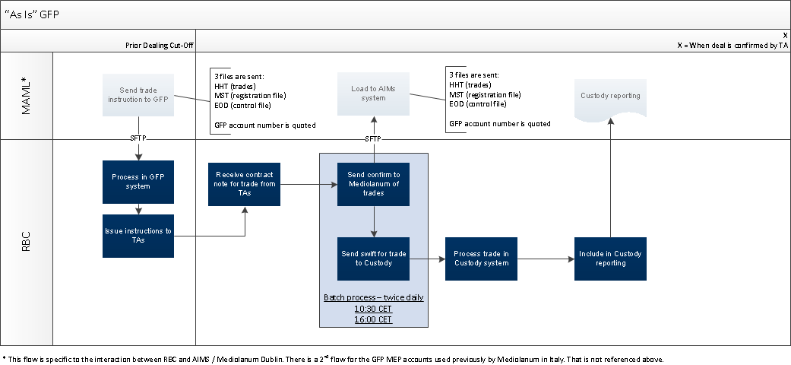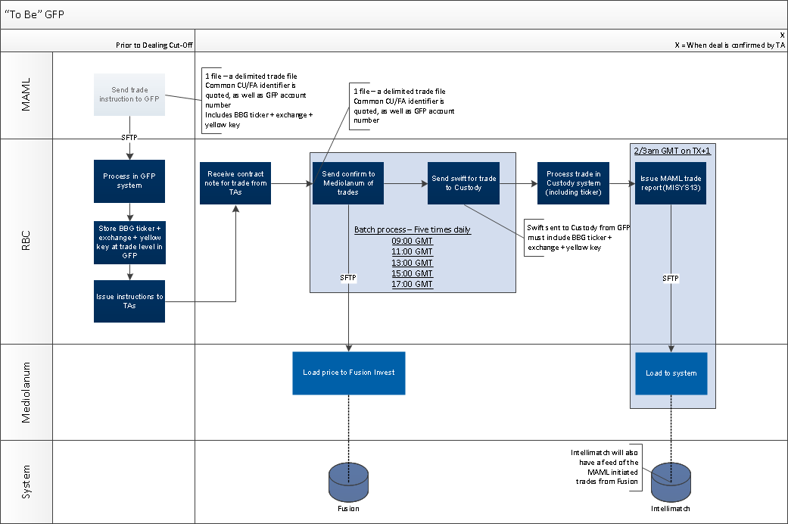

* 1. Requirements
     1. Functional Requirements

|  |  |
| --- | --- |
| General Requirements | |
| Client Requirements  Product, Features & Options  Marketing & Sales  Communications  Credit & Risk  Other   |  |  |  |  |  |  | | --- | --- | --- | --- | --- | --- | | ID | Requirement | Priority  1=high  5=low | Stability  High  Med  Low | Origin | Benefit | | CR1 | Ability to instruct GFP in a delimited file format | 1 | High | Mediolanum | To instruct trades | | CR2 | Confirmation trade file issued by GFP in a delimited trade format | 1 | High | Mediolanum | To load information to Fusion | | CR3 | Ability for Mediolanum to instruct GFP not quoting the GFP account number, but instead the common FA/CU identifier | 1 | High | Mediolanum | To instruct trades | | CR4 | Confirmation trade file issued by GFP must report the common FA/CU identifier | 1 | High | Mediolanum | To load information to Fusion | | CR5 | Frequency of the confirmation file must be increased | 1 | High | Mediolanum | To load information to Fusion | | |
| Operational Requirements | |
| Operational Requirements   |  |  |  |  |  |  | | --- | --- | --- | --- | --- | --- | | ID | Requirement | Priority  1=high  5=low | Stability  High  Med  Low | Origin | Benefit | | OPR1 | A new field must be created at the Account Number level in GFP.  A screen show of where this new code should be added is included in Appendix 1. | 1 | High | GFP | To meet client requirement | | OPR2 | The new field referenced in OPR1 should be named “FA/CU Common ID” | 1 | High | GFP | To meet client requirement | | OPR3 | For each existing Mediolanum account there must be once off load of data found in Appendix 2 to the new field referenced in OPR1. | 1 | High | GFP | To meet client requirement | | OPR4 | A new field must be created at the Trade level in GFP. | 1 | High | GFP | To meet client requirement | | OPR5 | This new field referenced in OPR4 must be called Bloomberg Security ID | 1 | High | GFP | To meet client requirement | | OPR6 | In the “as is” process Mediolanum instruct RBC using 3 files:  HHT: Trades  MST: Registration File  EOD: Control File  RBC confirm the trades back to Mediolanum when a price is confirmed also through these same 3 files – populating fields that are blank when Mediolanum instruct.  All files are in a specific file format that Mediolanum cannot use in the future model (per CR1/CR2).  In the “to be” process Mediolanum will instruct using only 1 file. RBC will confirm using only 1 file.  This 1 file will be a delimited version of the existing HHT file. Please refer to Table 1.1 below for a list of fields, and to Appendix 3 for a copy of the “as is” and “to be” file formats.  It must be possible to load the trades to GFP even if no accompanying MST and EOD file are sent by the client, and vice versa | 1 | High | GFP | To meet client requirement | | OPR7 | The current naming convention of the file sent by Mediolanum to RBC is be xxxhht.seq where  xxx corresponds to the different underlying fund of funds and seq is a hexadecimal sequential file number (0,1,....,9,a,b,....,f).  Given the changes being undertaken in the BRD, this convention can also be reviewed – also the split into different underlying funds triggering different filenames can be revised.  Subject to Mediolanum’s agreement the filename could be in the format MAML_TRADEFILE_GFP_SEQ_YYYYMMDD  - where the sequence is used to avoid a situation where duplicate file is sent in error. | 1 | High | GFP | To be aligned with the existing functionality to load files at GFP level | | OPR8 | Mediolanum will quote the new account identifier in field 1 of the “to be” file. They will not quote the GFP account number.  RBC must manage a mapping between the client code and the GFP account code. | 1 | High | GFP | To meet client requirement | | OPR9 | As well as the format change referenced in OPR6, the file must also include a new field where the client will quote the new Bloomberg Security ID.  This data will be in field 21 of the instruction and must be loaded to the new field referenced in OPR5. | 1 | High | GFP | To meet client requirement | | OPR10 | The frequency of delivery of the confirmation version of the HHT file must increase. It should be scheduled to be sent to the client system at the times:   1. 10:00 CET 2. 12:00 CET 3. 14:00 CET 4. 16:00 CET 5. 18:00 CET | 1 | High | GFP | To meet client requirement | | OPR11 | The GFP trades are interfaced into Focus by swift:  MT541 for a subscription  MT543 for a redemption  MT540 for a subscription into a target fund operating on a “cleared funds” basis.  The new Bloomberg security reference must form part of the swift instruction to Focus.  It must be stored in a new field in Focus that does not currently exist. The requirements for this field will be document separately under MISYS-03 (please refer to Dependencies section).  The value received from Mediolanum in field 18 of the FTP file must be sent to Focus in tag :35B::FIAN// inside the block :16R:FIA and :16S:FIA.  The format must be as follows:  :16R:FIA  :35B:/XX/BGSC Ticker Exchange Yellow Key  :16S:FIA  e.g.  :16R:FIA  :35B:/XX/BGSC MEDINDL ID Equity  :16S:FIA  Please refer to full example in Appendix 4.  The format would be applied only if the Bloomberg ID is quoted at trade level. If nothing is quoted (i.e. for clients other than Mediolanum), the swift MT54x format remains the same as the current format – no FIA block is quoted. | 1 | High | GFP | To meet client requirement |   Table 1.1 Field description  The field names in the “as is” and “to be” versions of the file will be the same. For reference the character positions of the fields in the “as is” flat file are included below. Any field in the current file that is not used, has been removed in the “to be” file format.   |  |  |  |  |  |  |  | | --- | --- | --- | --- | --- | --- | --- | | ID | Field Name | Position  “as is” file | Description | Format | Populated  “In” Flow | Populated  “Out” Flow | | 1 | account-no | 4-13 | Account Number  Mediolanum will not quote the GFP account number, they will quote the new CU/FA identifier. The same value will be used in the confirmation file from GFP. | Alpha Numeric | Yes | Yes | | 2 | h-status | 14 | Mediolanum will instruct with ‘P’ for Pending i.e. not processed.  GFP will reply with ‘H’ for History, i.e. processed or ‘R’ for Rejected | Alpha | Yes | Yes | | 3 | entry-date | 16-23 | Reception date of the orders in GFP | DDMMYYYY | No | Yes | | 4 | order-date | 24-31 | Trade or Dealing Date of the trade. In the case of the confirmation file, this is the date advised by the TA, which might not be the date that was quoted in the file from Mediolanum. | DDMMYYYY | Yes | Yes | | 5 | tran-code | 32-34 | Required values are:  “CTB”: Subscription  “BTC”: Redemption | Alpha | Yes | Yes | |  |  |  |  |  |  |  | | 6 | order-amt | 36-48 | Gross amount instructed | Numeric (2 decimals) | If trade placed in Amount | Yes | | 7 | order-shares | 49-61 | Units instructed | Numeric (3 decimals) | If trade placed in Units | Yes | | 8 | confirm-no | 62-73 | GFP transaction reference number | Alpha Numeric | No | Yes | | 9 | price-used | 74-86 | Price used / NAV per unit | Numeric (4 decimals) | No | Yes | |  |  |  |  |  |  |  | | 10 | date-settled | 95-102 | Actual Value Date provided from the TA.  In the current environment this is the receipt date of the order, but this will be updated as part of the development. | DDMMYYYY | No | Yes | | 11 | receipt-amt | 103-115 | Amount on the order | Numeric (2 decimals) | No | Yes | | 12 | receipt-shares | 116-129 | Units on the order | Numeric (3 decimals) | No | Yes | | 13 | local-currency | 156-158 | Trade currency (ISO currency code) | Alpha | Yes | Yes | | 14 | loc-curr-rate | 159-174 | FX rate applied to the transaction if required | Numeric (9 decimals) | No | Yes | | 15 | all-shares | 175-177 | Client can fully redeem shares:  “Yes”: Full redeem  Blank or “No”: No full redemption | Alpha | Yes | Yes | | 16 | trn-id | 181-200 | Client transaction number | Alpha Numeric | Yes | Yes | |  |  |  |  |  |  |  | | 17 | fund-id-ext | 378-397 | ISIN Code for the target fund in format  “ISIN:” followed by ISIN code, e.g. ISIN: LU0000000011 | Alpha Numeric | Yes | Yes | | 18 | Bloomberg-security- code | N/A - New | New security identifier in the format:  [Bloomberg ticker] [Exchange] [Yellow Key]  e.g. IE0004462408 would be MEDINDL ID Equity   * + - MEDINDL is the ticker for the class on the Challenge Cyclical fund     - ID represents that the fund is listed on the Irish stock exchange     - Equity represents the asset class (or Bloomberg yellow key) | Alpha Numeric | Yes | Yes | |
| Third Party Requirements |
| Third Party Requirements |
| Measurement Requirements |
| Measurement Requirements |

* + 1. Non – Functional Requirements

|  |
| --- |
| Non- Functional Requirements |
| Audit  Business Continuity  Data Retention  Documentation / Training  Fraud  Privacy  Volume Impact  Security  Availability  Hardware  Software  Reliability  Scalability  Performance  Interface  Infrastructure |

|  |  |  |  |  |  |
| --- | --- | --- | --- | --- | --- |
| ID | Requirement | Priority  1=high  5=low | Stability  High  Med  Low | Origin | Benefit |
| SCL1 | The new fields created at account and trade level should be scalable – i.e. used for other clients if ever required in the future.  However they must have no impact on any current flow or exchange of information for clients other than Mediolanum | 1 | High | GFP | To avoid BAU impact |

1. Sign off Block

|  |  |  |  |  |
| --- | --- | --- | --- | --- |
| Role | Name | Group & Function | Signature | Date |
| Project Manager | Noel Nolan | Mediolanum |  |  |
| Program Manager | Kate Cullen | RBC |  |  |

## Reviewers

Reviewers are acknowledging that they have reviewed the Business Requirements and are in agreement with the content.

|  |  |  |  |  |
| --- | --- | --- | --- | --- |
| Role | Name | Group & Function | Signature | Date |
| Mediolanum | Lizy Di Vetta | Mediolanum |  |  |
| Mediolanum | John Burrows | Mediolanum |  |  |
| Cronos | Steve Lazouras | Cronos |  |  |
| Cronos | James Shillingford | Cronos |  |  |
| SME | Marc Lingenheim | GFP |  |  |
| BSA | Karim Mouhoud | IT |  |  |
| BSA | Delphine Tempesta | IT |  |  |
| IT PM | Sebastien Paulissen | IT |  |  |

1. Appendix 1 – GFP Account Screenshot

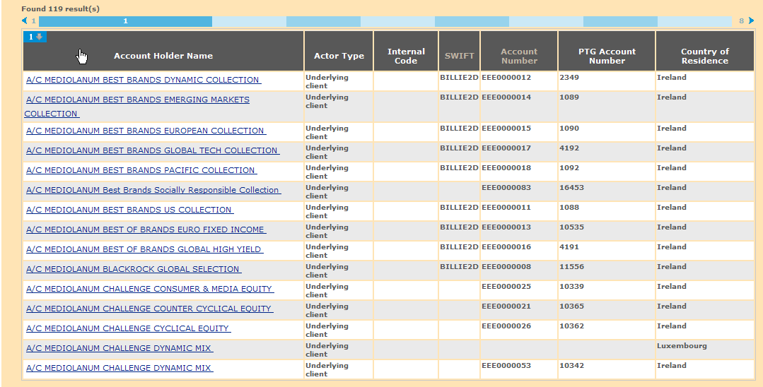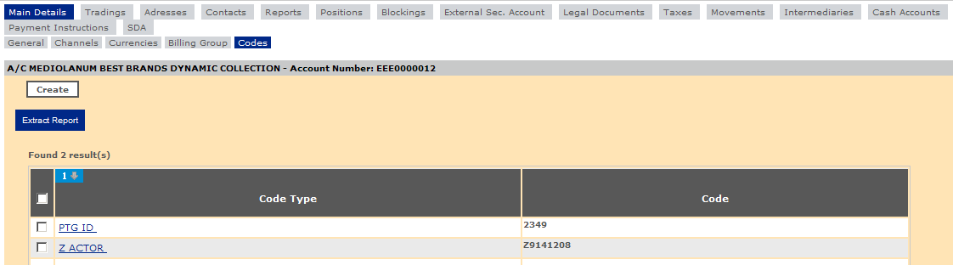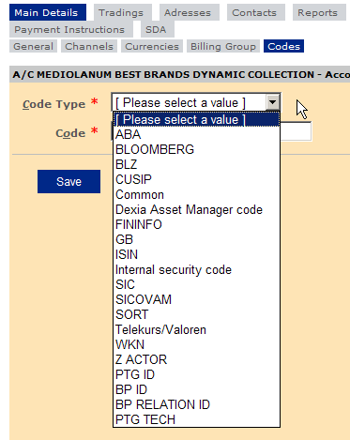

1. Appendix 2 – Mapping between GFP Account Number and FA/CU Common Fund Identifier

These do not include the Mediolanum Vita SPA Italy account opened in GFP under MEP0000001 which is out of scope for the new flow.



1. Appendix 3 – Sample “as is” and “to be” files

“As Is”

The samples are taken from the GFP -> Mediolanum flow. In the Mediolanum -> GFP some of the fields would be populated only with zeros or blanks.

  

“To Be”

The sample is in XLS for illustrative purposes but must be a CSV delimited file.

1. Mediolanum - > RBC (“In” Flow)



1. RBC -> Mediolanum (“Out” Flow)



1. Appendix 4 – MT54X Example

